60CM 3D hologram fan operation instruction:

1. Windows:

1.1 Find software folder “ XD60”

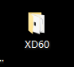

1.2 Click “XD60.exe” and open it.

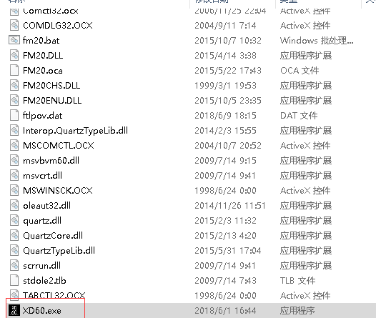

1.3 Connect hologram fan WiFi : Pass word: ”12345ftl” each fan has a ID, which starts with FTL-3numbers and a letter.

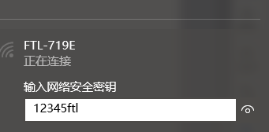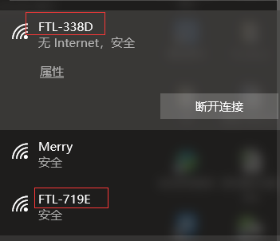

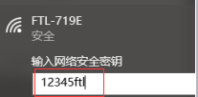

1.4 Add, delete and change content in playlist →

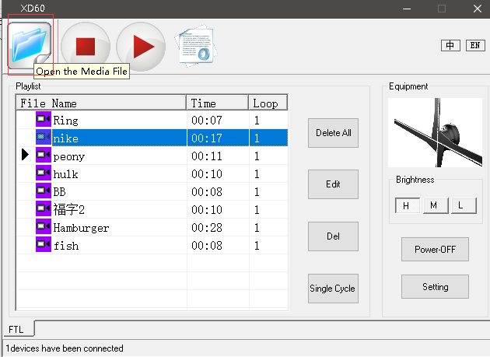

Brightness adjust



Insert content

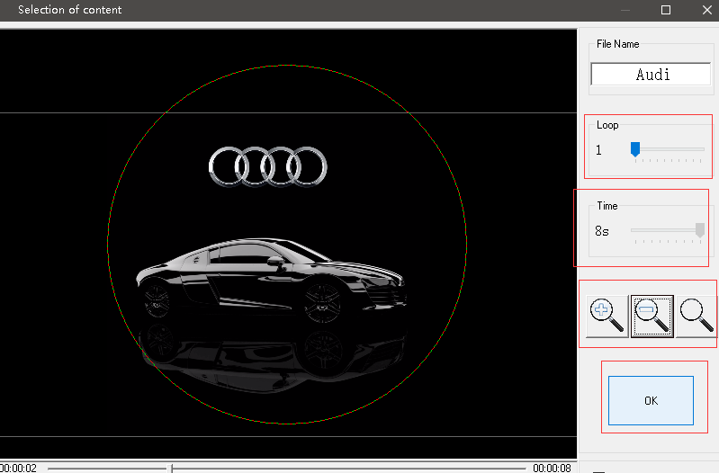

Confirm

Zoom in and out adjust video and picture size and make sure it is in middle of circle

Time

Edit file name

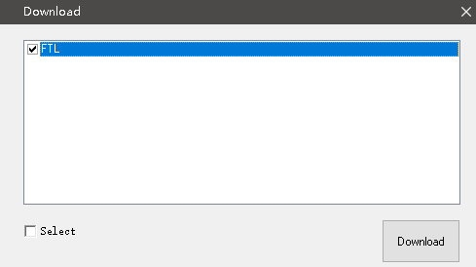

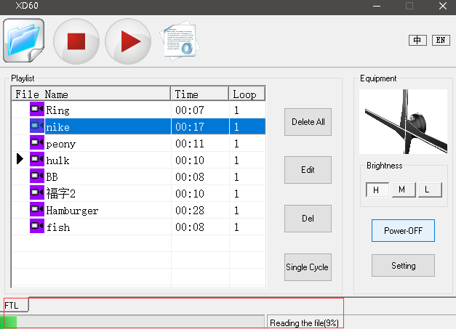

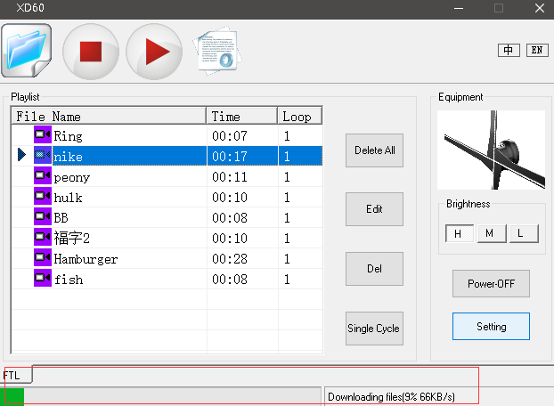

1. Mobile-Widows system:
   1. Install software : XD60.APK.1” in mobile. 
   2. Find App icon and connect 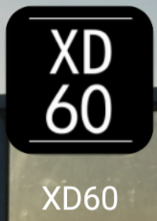

2.3 Connect WiFi and edit content

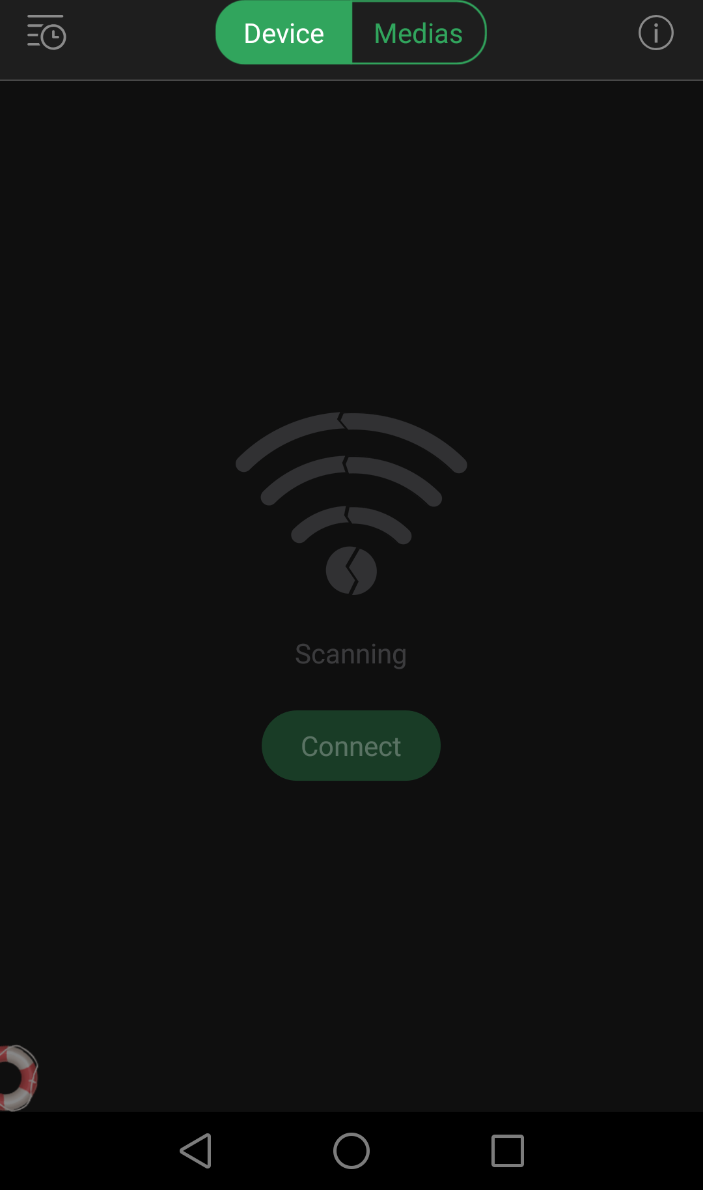

Scanning and connect WiFi:

Wifi code: 12345ftl

Play list

Add content

1. Mobile-IOS system:

3.1 Search XD60 in APP STORE

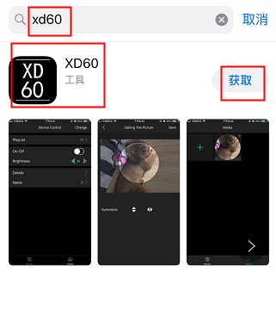

3.2 Connect device WiFi : WiFi code: 12345ftl

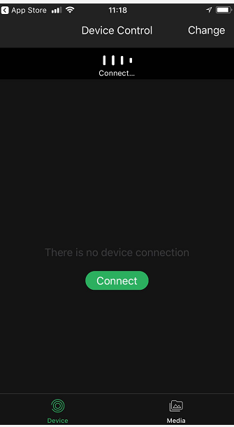

Play list： Add,delete and adjust content

Insert content

Connect device, FTL-XXXX

WiFi code: 12345ftl